**Wave Energy Prize**

SEWEC Test Plan



August, 1 2016

This page intentionally left blank

# **Content**

Content 3

List of Tables 5

List of Figures 6

1 Introduction 8

2 Test Objective 9

3 Test Facility 10

3.1 Wave Maker 12

3.2 MASK Orientation 13

4 Scaled Model Description 15

4.1 Device description 15

4.2 Power Take-Off description 16

4.3 Device properties [REDACTED] 17

4.4 Froude scaling 17

4.5 Other scaling or measures 17

4.6 Control strategy 18

5 Test Matrix and Schedule 20

5.1 Test matrix 20

5.2 Test schedule 20

6 Experimental Set Up and Methods 22

6.1 Mooring 22

6.2 Instrumentation 24

**6.3** **Safety** 25

7 Data Processing and Analysis 26

7.1 Data quality assurance and on-site processing 26

7.2 Data analysis 26

“Real Time” Data QA 28

Settling Interval and Time between Test Data QA 28

8 Data Management 31

9 References 32

Appendix A: Device electrical and mechanical drawings 33

Appendix B: PTO calibration results 34

Appendix C: Device Froude scaling 45

Appendix D: Detailed description of control strategy 51

Appendix E: Raw Data Channel list 53

Appendix F: Checklists for spot checks, software operation, readiness verification, and “real time” data QA 54

Appendix G: Team provided sensors – specifications and calibrations 56

Appendix H: Wave Energy Prize provided sensors – specifications and calibrations 62

Appendix I: Data analysis details 63

# **List of Tables**

*Table 1. Test waves* 20

*Table 2. Testing schedule* 20

# **List of Figures**

*Figure 1. General Schematic of bridge and MASK basin.* 11

*Figure 2. General view of new segmented wavemaker in MASK Wavemaking Facility. Paddles are highlighted in red and the control cabinets are highlighted in bright blue.* 12

*Figure 3. MASK carriage shown below the bridge at the center of the bridge.* 12

*Figure 4. General wavemaker characteristics and design.* 13

Figure 5. MASK reference orientation, note that the orientation here is different than that in Figures 1 and 3. 14

*Figure 6. Device working principle (update this as needed).* 15

*Figure 7. Device full-scale dimensions [REDACTED]..* 15

*Figure 8.Schematic of SEWEC butterfly valve calibration setup.* 17

*Figure 9. Mooring layout diagrams.* 24

Figure 10. Data flow and processing steps 27

This page intentionally left blank

# **Introduction**

The Department of Energy (DOE) launched the Wave Energy Prize (WEPrize) Competition as a mechanism to stimulate the development of new wave energy converter devices that have the prospect of becoming commercially competitive in the long run. In the Final stage of the competition, nine teams will test their 1/20th scale devices at the US Naval Surface Warfare Center Carderock Division (NSWCCD) Maneuvering and Seakeeping Basin (MASK) in West Bethesda, MD. Each contestant will prepare their device for one week and then test their device for one week at the MASK basin in Summer/Fall 2016. This testing program will measure the performance of each device tested to determine the WEPrize winners.

The purposes of the Team Test Plan are to:

* Plan and document the 1/20th scale device testing at the Carderock MASK basin;
* Document the test article, setup and methodology, sensor and instrumentation, mooring, electronics, wiring, and data flow and quality assurance;
* Communicate the testing between the Finalist team, Carderock, Data Analyst (DA) and the Prize Administration Team (PAT);
* Facilitate reviews that will help to ensure all aspects (risk, safety, testing procedures, etc.) have been properly considered;
* Provide a systematic guide to setting up, executing and decommissioning the experiment.

The team test plan is a WEPrize required document and will be owned/managed by the Carderock Test Leads and DAs, and is intended to be a “living document” that will evolve continuously prior to the MASK basin testing.

# Test Objective

The top level objective of the 1/20th scale device testing is to obtain the necessary measurements required for determining Average Climate Capture Width per Characteristic Capital Expenditure (ACE) and the Hydrodynamic Performance Quality (HPQ), key metrics for determining the WEPrize winners [1].

# Test Facility

All testing will be conducted in the Maneuvering and Seakeeping basin (MASK) at Carderock Division, Naval Surface Warfare Center located in Bethesda, Maryland. The MASK is an indoor basin having an overall length of 360 feet, a width of 240 feet and a depth of 20 feet except for a 35-foot deep trench that is 50 feet wide and parallel to the long side of the basin. The basin is spanned by a 376-foot bridge supported on a rail system that permits the bridge to transverse to the center of the basin width as well as to rotate up to 45 degree from the centerline as seen in Figure 1. Figure 1 does not include the physical update of this wavemaker system, but a drawing of the new paddle layout can be seen in Figure 2. The MASK Carriage is suspended beneath the bridge and can travel along the rails by the rollers and drive system. There is an arresting gear to prevent the carriage from hitting the end stops and this limits the travel along the bridge. The carriage has 6’ x 10’ moon bay in the center which allows for models and instrumentation to be mounted. A photo of the carriage is shown in Figure 3. Along the two ends opposite of the wavemakers are beaches with a 12 degree slope. The beaches are constructed of 7 layers of concrete sections and are effective in mitigating the mass flux of water back into the tank during wave generation. The hydrodynamic properties of the beaches can be found in [2].



*Figure 1. General Schematic of bridge and MASK basin.*



*Figure 2. General view of new segmented wavemaker in MASK Wavemaking Facility. Paddles are highlighted in red and the control cabinets are highlighted in bright blue.*

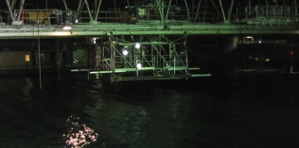

*Figure 3. MASK carriage shown below the bridge at the center of the bridge.*

## Wave Maker

The new wavemaker is rendered with respect to its general install position in *Figure 2*. The wavemaker system consists of 216 paddles. There are 108 paddles along the North edge of the basin, 60 paddles in a ninety degree arc, and 48 paddles along the West edge of the basin. The paddles are grouped in sets of eight paddles per control cabinet. The 27 control cabinets are then joined via three marshaling cabinets, and ultimately the marshaling cabinets are connected to the main control station at the second floor of the MASK control room. The cabinets and control room are generally illustrated in *Figure 2*.

A more detailed view of the wavemaker paddles is provided in *Figure 4*. The paddles have a hinge depth of 2.5 m (8.2 ft) and a pitch (centerline to centerline spacing) of 0.658 m (25.9 in.). The wavemaker system is a dry back, force feedback system. The paddles are moved using hydrostatic compensation with air tanks and bellows and with sectors attached to the wavemakers with an A-frame type structure. The sector has a timing belt attached which runs on the topside of the sector. The timing belt runs through a pulley box powered with an encoder controlled motor. The motor is used to control the real-time quick motions of the paddle. The force feedback of the paddle is provided via a force transducer mounted at the bellows and sector interface to the paddle.

The wavemaker is controlled via runtime software located on the main control computer using Edinburgh Designs Limited (EDL) software. The software allows entering specific regular wave conditions or it can be programmed to generate irregular seas via the input of “experiments files”.

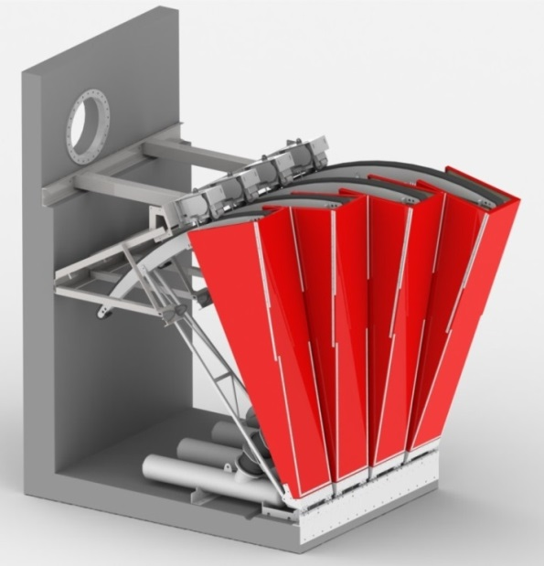

*Figure 4. General wavemaker characteristics and design.*

## MASK Orientation

With respect to the MASK basin, the reference frame is illustrated in Figure 5. Its operational origin is located at the interior intersection of the northwest and northeast walls and vertically at the nominal 20 ft. water level. The positive *x*-axis is aligned along the shorter northwest wall and the positive *y*-axis along the longer northeast wall. Waves propagating parallel with the *x*-axis (toward the long beach) are defined as having a mean wave direction, *β₀*, of zero degrees and waves propagating parallel with the *y*-axis as 90 degrees. This convention defines the wave direction as the direction the waves are traveling toward.

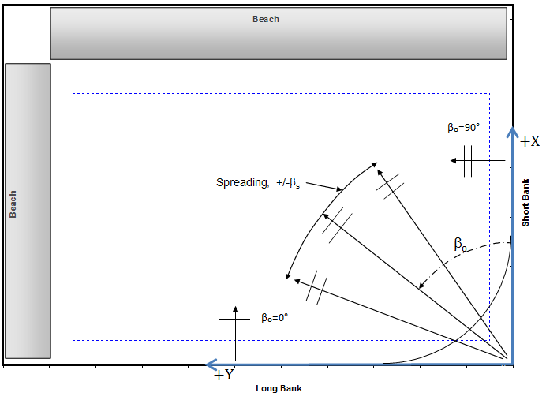

Figure 5. MASK reference orientation, note that the orientation here is different than that in Figures 1 and 3.

# Scaled Model Description

## Device description

The device’s principle of operation is shown in *Figure 6* with the wave moving right to left, so the “stern” is on the left and the “nose” is on the right. As the wave front approaches, the device pitches upwards. The internal fluid remains in the same location. A pressure differential is developed between the two chambers in the device. The devices pitch causes the air to pass through a turbine located in the mid-point of the air partition of the device (shown as a straight black line in *Figure 6*). As the wave crest reaches the stern the rear nose stops the device from going too far, and starts to help the device to pitch forward. After the wave passes, the front nose starts to pitch downwards as seen in *Figure 6* right. The air then moves in the opposite direction back through the bidirectional turbine. The devices’ double nose configuration allows the trim angle to be adjusted to better suit the unique wave conditions experienced at any time. This adjustment has resulted in a doubling of the operating bandwidth, thus increasing the device operating power capture. It will be possible to remotely control the device reaction to different sea states but it is not considered necessary or feasible to attempt to adjust the device to individual incoming waves. In other words, the device may adapt to established sea states which typically endure for periods up to several days and which can now be forecast in advance.

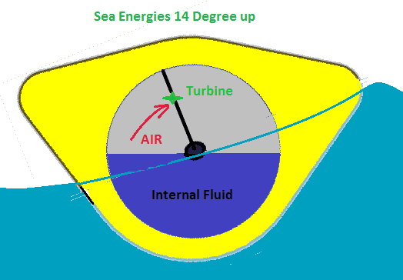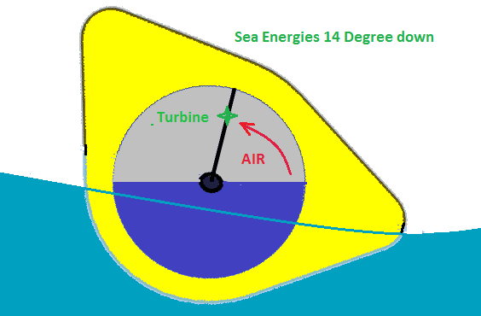

*Figure 6. Device working principle (update this as needed).*

*Figure 7. Device full-scale dimensions [REDACTED]..*

1/20th Scale Prototype

**Drawing VLV-ASMO1 [REDACTED]** shows the custom built butterfly valve with stepper motor actuator installed in the top 6 inch nozzle – see PTO description below.

This structure is extended radially to the nose and stern sections via aluminum plates bolted to the back of the main pipe flanges. These plates are shown in dark blue in the viewer model **Sewec Main Assembly Internal 16-04-17.EASM**

The structure described above is fitted with 20 x 2” full width ABS tubes which can hold stainless steel ballast bars. Buoyancy is added to make the final device profile using hot wire cut polystyrene foam. The final assembly is then wrapped in FRP.

## Power Take-Off description

In the case of the SEWEC system, the wave power is converted into flow Q [m3/s] and pressure difference DP [N/m2] without a mechanical interface. Power take-off is by throttling the airflow between the two chambers. Throttling is done by fixed orifice plates in the vertical partition (see drawing MCVPT-01) in parallel with a stepper motor actuated butterfly valve, shown in drawing VLV-ASMO1. Throttling the airflow results in a pressure difference between the two chambers, measured directly by fast response DP transmitters. Pressure difference is the dynamic component of the power produced. The kinematic component, airflow, is measured by tracking the volume changes in each chamber, using depth probes attached inside the device. The depth probes are curved and aligned parallel to the circumference of the internal water chamber. Each of the two chambers is fitted port and starboard with a circumferential depth probe and each of these is twinned with a straight depth probe close to the center partition which is used to correct for the level difference between chambers resulting from the air pressure difference. The device thus has a total of eight depth probes. The depth probes will be spot-checked using a digital inclinometer at MASK. For equations that are going to be used to derive depth probe measurements to the kinematic component please see Appendix H. As the device rotates in a pitching motion, immersion of the level probe changes, effectively measuring the air volume in the chamber. Conversion from measured depth to chamber volume is described in Appendix B. This approach assumes the water surface in the chamber is flat and level fore and aft. Any rolling is accounted for by having depth probes both port and starboard and taking the average. In our experience the difference between port and starboard measurements is not significant and video recordings have shown no sloshing.

In previous testing using fixed orifice plates we have demonstrated that airflow can also be calculated using the pressure difference between the chambers and the flow vs DP characteristic of the orifice plate – although this technique contravenes the rule requiring use of independent dynamic and kinematic variables. However, for the 1/20th test we have calibrated the butterfly valve, i.e. measure its flow vs DP characteristic for a series of valve positions. Since the valve is position controlled, knowing its position and the DP value does provide a second way of computing the airflow. This calibration has been done at San Jose State University under the supervision of Professor Liat Rosenberg, using the valve mated with actuator and positioner. A steady flow calibration was used instead of the piston procedure used to calibrate orifice plates for the 1/50th scale model. The distance between the DP sensor and the orifice is 18 inches in the 1/20th scale model. In the test setup it is 19 inches.

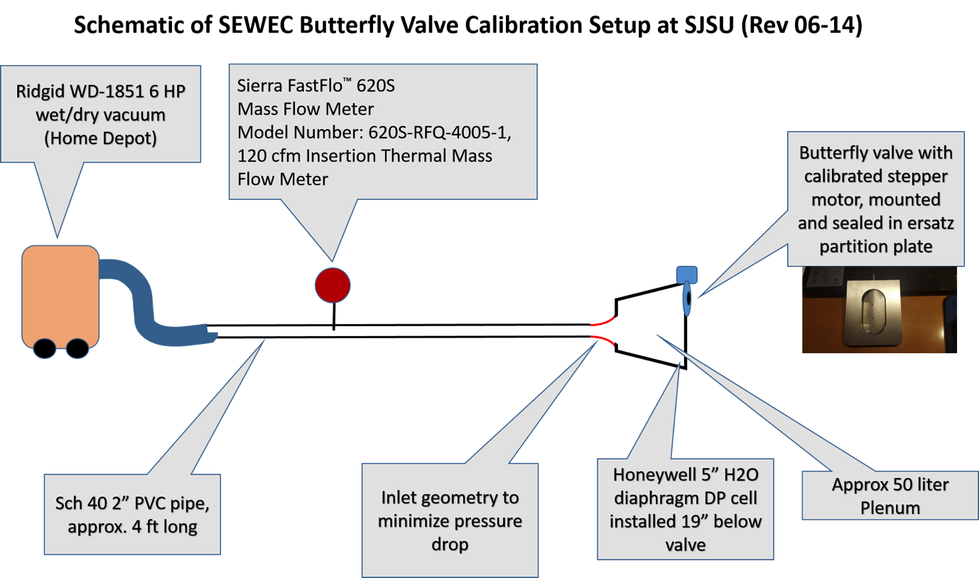

*Figure 8.Schematic of SEWEC butterfly valve calibration setup.*

**Post Test Notes for Section 4.2**

The orifice plates were not used during the testing. Only the butterfly valve was used during the testing.

The depth probes were not spot-checked using inclinometer. Instead they were extensively spot-checked using a reference wave probe provided by Carderock. The geometry (shape) and position (3D coordinates) of each depth probes, relative to the device, were determined using a 3D surface tracker.

## Device properties [REDACTED]

## Froude scaling

Table **[REDACTED]**

## Other scaling or measures

**Accounting for Air Compressibility when Scaling**

We have reviewed the references provided by the judges and considered the following ways of accounting for air compressibility.

1. *Increase the volume of air undergoing cyclical compression and expansion by a factor of twenty.* The volume of air in our device is approximately 140 liters. A twenty times larger volume is 2.8 m3, e.g. a sphere of 6 feet diameter. We could not include this on the device – such a volume would have to be held in a rigid closed container and mounting such a container on our device would totally obscure its dynamic behavior (principally pitching mass, C of G and moment of inertia. Piping our pitching, heaving and surging device up to a bridge based container without imparting restraining or pressure based loads on our device would also be impossible. We note this could be done for the Portuguese OWC referenced in the Falcao and Henriques paper, but this involved a land based OWC where the problems mentioned above do not arise.
2. *Reduce the air pressure in the device by a factor of twenty*. Although the judges indicated a preference for measure (i) in an April response to our team, the possibility of running at reduced pressure to give the same effect was also raised. This is uniquely possible in principle with the SEWEC type of OWC because the device works without inhaling and exhaling air. The same air is alternately compressed, expanded and partially exchanged between two chambers, isolated from the atmosphere. On hearing that this could be a solution to the scaling problem we immediately changed the design of our scale model’s to withstand vacuum. Appendix C details the measures we have taken to enable testing under vacuum. Our device is designed to withstand the buckling loads and is closed. Minor leaks should be easily overcome by renting a vacuum pump to get down to 0.05 bar in 20 minutes.

Tests at the University of Maine in the week of July 10th showed we could get down to an absolute pressure of 0.28 psia using a 10 m3/hour oily vane vacuum pump with a 3/8” hose in about 20 minutes. The pressure was then set to 0.75 psia and the vacuum source disconnected. Over 10 minutes the pressure rose to 0.80 psia. This indicates a pretty good seal. For the test at Carderock we will rent a vacuum pump with vacuum control locally and connect it to the device with a coiled hose (like trucks have for their braking systems).

**Post Test Notes for Section 4.5**

During the testing the vacuum pump was connected to the device and turned on to maintain the absolute pressure inside the device. Disconnecting the vacuum pump caused a rapid increase of absolute pressure inside the device.

## Control strategy

The adaptive control strategy includes optimizing the ballast configuration for the particular sea state as well as changing the damping involved in the PTO.

**Optimizing Ballast Configuration [REDACTED]**

We envisage SEWEC devices ultimately using machine learning to adapt optimally to the expected/actual sea state. Ballast changes in the 1/20th scale model are made by a combination of manually moving ballast weights between tests, based on numerical modelling correlated with previous tests planned at the University of Maine in June, prior to shipment to Carderock.

**[REDACTED]**

**Butterfly Valve Adjustment**

This will be done from the bridge in the first ten minutes of the test. Valve position will be set using the SEWEC laptop, then moved in discrete increments to seek out the setting for optimum power. In this optimization phase we would like to have the following parameters graphically displayed:

* Power – updating trace over time
* Pitch amplitude – ditto
* Phase shift between wave height, device pitch and air pressure

# Test Matrix and Schedule

## Test matrix

The incident wave conditions for the 1/20th scale experiments at NSWC Carderock’s MASK are shown in *Table 1*. Carderock will perform wave environment calibration in Summer 2016. The result of this calibration is shown in Appendix E.

*Table 1. Test waves*

|  |  |  |  |  |  |  |
| --- | --- | --- | --- | --- | --- | --- |
| **Type** | **Number** | **TP [s]** | **HS [m]** | **γ (gamma)** | **Direction** | **Spreading** |
| IWS (JONSWAP) | 1 | 1.63 | 0.117 | 1.0 | 10.0 | ∞ |
| 2 | 2.20 | 0.132 | 1.0 | 0.0 | ∞ |
| 3 | 2.58 | 0.268 | 1.0 | -70.0 | ∞ |
| 4 | 2.84 | 0.103 | 1.0 | -10.0 | ∞ |
| 5 | 3.41 | 0.292 | 1.0 | 0.0 | ∞ |
| 6 | 3.69 | 0.163 | 1.0 | 0.0 | ∞ |
| LIWS (JONSWAP) | 7 | 3.11 | 0.395 | 3.3 | -30.0 | 3.0 |
| 8 | 2.50 | 0.460 | 3.3 | -70.0 | 7.0 |
| RWS (4-parameter JONSWAP) | 9 | 3.22 | 0.076 | 2.0 | -70.0 | 7.0 |
|  | 1.61 | 0.108 | 2.0 | 0 | 10 |
| 10 | 3.32 | 0.079 | 2.0 | -70.0 | 7.0 |
|  | 1.93 | 0.065 | 2.0 | -10 | 10 |

## Test schedule

The standard test schedule for the testing week is shown in Table 2. This schedule will be customized for each team as appropriate, and to include spot check for sensors.

*Table 2. Testing schedule*

|  |  |  |
| --- | --- | --- |
| **Date/Time** | **Event** | |
| Monday | MASK installation and work-in | |
| 7:00 | Morning Huddle | |
| 7:10 | Contestants will be moving their device from the assembly area to the installation area, installation and verifying operation | |
| Tuesday | Continued installation and work-in | |
| 7:00 | Morning Huddle | |
| 7:10 | Contestants continue moving their device from the assembly area to the installation area, installation and verifying operation | |
| 2:00 | Readiness verification | |
| 3:00 | Baseline 1 run | IWS Wave 2 |
| 4:00 | Baseline 2 run | IWS Wave 5 |
| 4:20 | Contestants pack up for evening | |
| Wednesday | Full Test Day | |
| 7:00 | Morning Huddle | |
| 7:15 | Contestants set up for testing and perform pre-test checks | |
| 8:00 | Run 1 (Baseline 1) | IWS Wave 2 |
| 9:00 | Run 2 (Baseline 2) | IWS Wave 5 |
| 10:00 | Run 3 | IWS Wave 1 |
| 11:00 | Run 4 | IWS Wave 3 |
| 12:00 | Lunch | |
| 1:00 | Check Run 1 (Baseline 1) | IWS Wave 2 |
| 2:00 | Run 5 | IWS Wave 4 |
| 3:00 | Run 6 | IWS Wave 6 |
| 4:00 | Check Run 2 (Baseline 2) | IWS Wave 5 |
| 5:00 | Contestants pack up for evening (also a 30 minute buffer) | |
| Thursday |  | |
| 7:00 | Morning Huddle | |
| 7:15 | Contestants set up for testing and perform pre-test checks | |
| 8:00 | Check Run 3 (Baseline 1) | IWS Wave 2 |
| 9:00 | Run 7 | RWS Wave 1 |
| 10:00 | Run 8 | RWS Wave 2 |
| 11:00 | Run 9 | LIWS Wave 1 |
| 12:00 | Lunch | |
| 1:00 | Run 10 | LIWS Wave 1 |
| 2:00 | Check Run 4 (Baseline 2) | IWS Wave 5 |
| 3:00 | Backup Run 1/ Contestant Testing | TBD |
| 4:00 | Backup Run 2/ Contestant Testing | TBD |
| 5:00 | Perform final daily data QA checks and test reporting (may start earlier if testing permits) | |
| Friday |  |  |
| 7:00 | Morning Huddle | |
| 7:15 | Contestants set up for testing and perform pre-test checks | |
| 8:00 | Backup Run 3/ Contestant Testing | TBD |
| 9:00 | Backup Run 4/ Contestant Testing | TBD |
| 10:00 | Backup Run 5/ Contestant Testing | TBD |
| 11:00 | Backup Run 6/ Contestant Testing | TBD |
| 12:00 | Lunch | |
| 1:00 | Contestants pack up for shipping | |

**Post Test Notes for Section 5.2**

The test schedule was modified and all test waves were run. Please see the test results spreadsheet for a list of waves that were run and the order for which they were run.

# Experimental Set Up and Methods

## Mooring

Following extensive simulations using the Carderock test waves (as detailed in Upload No 2817: Mooring Configuration Recommended Sewec of the SEWEC prize site test plan), we have decided, with input from Carderock, on the following mooring configuration.

Following the descriptive slides below, the device will have three mooring tethers with elastomers incorporated and designed to mitigate the expected snatch loads in the more energetic test waves.

The main mooring line extends from the Sewec bow mooring float against the direction of the waves to an anchor point on the tank floor14 metres horizontally from the float. Two subsidiary mooring lines will extend aft to port and starboard from the float at 120 degrees and 240 degrees to additional anchor points on the tank floor. The mooring lines will incorporate load cells positioned to measure mooring loads.

The anchor points are defined using Cartesian co-ordinates, with the convention in the diagrams below, i.e.: (y, x) as follows in meters. NB: Z is the vertical towards the tank floor and is not referenced here, the length of the tether including catenary being given instead.

Anchor point 1 Position (14, 0) Length 16.5 meters

Anchor point 2 Position (8.9, -5.2) Length 14.0 meters

Anchor point 3 Position ( -12.2, -7) Length 16.5 meters

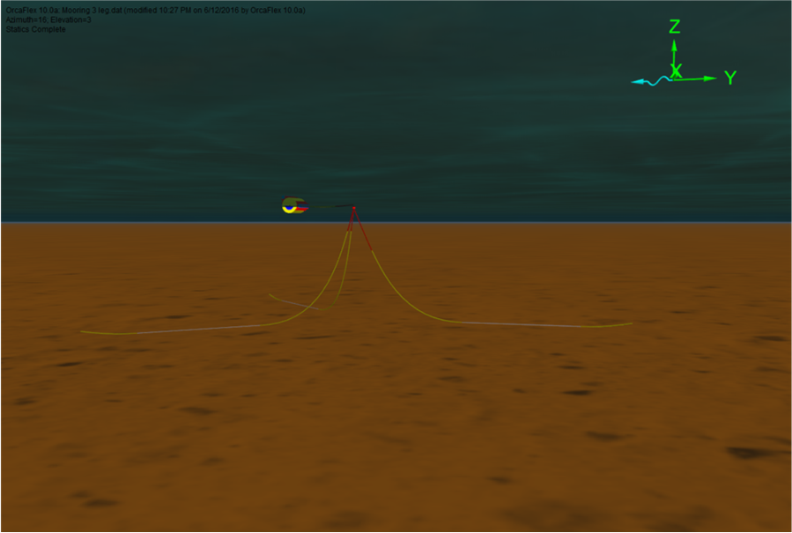

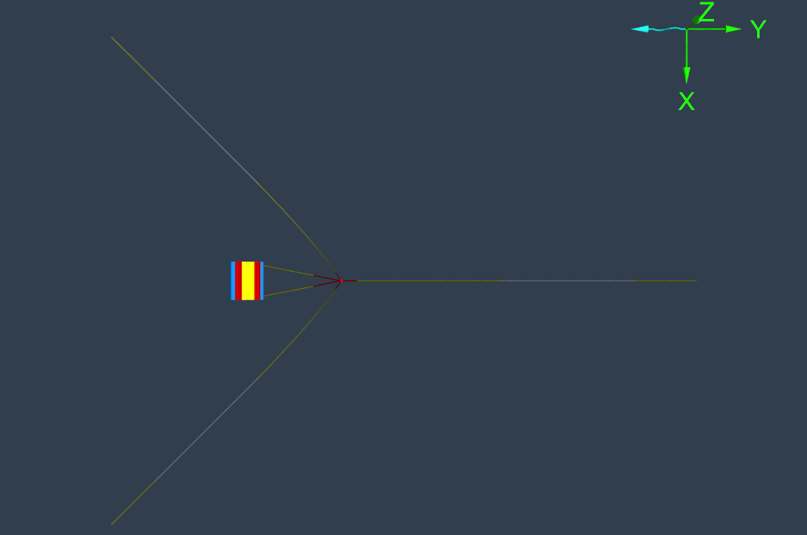

*Figure 9. Mooring layout diagrams.*

## Instrumentation

The Team Instrumentation comprises two bi-directional differential pressure sensors, part number 160PC1D36 and 8 depth probes contained within the device as well as an absolute pressure sensor. The physical properties and details of the sensors are described in appendix H. General descriptions of the measurement strategies are given below:

The differential pressure sensors are shipped from the manufacturer with a certificate of conformance assuring the accuracy specified on the data sheets. The sensors shall be monitored with NSIT compliant calibrated instrumentation.

The depth probes are installed in the device providing a measurement of air volume in each side of the device.

The maximum orifice area we can install is 2 x 45 mm orifices, together with a fully open valve. This gives an equivalent total flow area of 0.0058 m2. At the maximum DP sensor scale of 5 in H2O, this corresponds to a maximum air flow of 0.16 m3/s if operated at atmospheric pressure. For operation at 0.05 ATM, the volumetric flow would be a factor 200.5 higher. We don’t expect to reach these maxima of course!

* 1. **Safety**

For the Sewec internal water depth probes:

1) The voltage used to produce the current shall remain below 50VDC. This is universally accepted in industry as a voltage level that does not require specific safety precautions such as enclosures to protect personnel working with or around such equipment. The reason for this is that 50V is insufficient to produce a lethal current through an exposed individual due to the festivity of the human body.

The actual current through the probes will be lower than 1A; 1A was specified to ensure adequate thermal capability (i.e. current output) of the probe amplifiers would be available at the test site.

2) The conductors carrying the probe excitation currents shall be sized at 24AWG minimum to ensure heating of the conductors is minimized negating the risk of burns to personnel.

3) The probe amplifier outputs shall be isolated from earth to ensure all return currents flow through the specified conductors and NOT the water that personnel could be exposed to in the tank.

4) The probe amplifiers shall be turned off prior to any personnel coming into contact with the wave tank/going out in the punts.

# Data Processing and Analysis

## Data quality assurance and on-site processing

Data collection will start 2 minutes before waves are started and continue for at least 2 minutes once wave generation stops. This will ensure that the data captures the initial conditions and ramp-up/down.

“Raw” data from the Natural Point motion tracking and from the National Instruments (NI) measured power/loads/other are collected on two different systems and stored in separate text files. The motion tracking data are stored in a CSV file while the data from NI DAS are stored in a tab delimited text file

## Data analysis

The data processing and analysis is into two parts: 1) data quality assurance (QA) that will ensure that quality, consistent and error free data are used in data analyses and 2) data analysis to calculate the performance metrics used in judging.

The data flow and processing steps are shown in Figure Figure 6. The DA responsibilities are outlined in Table 1 and Table 2.

Individual Test Data Flow, Display and Reporting

Post Test Analysis

Wave Sensors

Motion Tracking System

Mooring Loads Sensors

WEC PTO Sensors

Carderock DAS

Write to optical Disc

Signal Conditioning

Unit Conversion

Data Formatting

DAS Real Time Data Display

Test-by-Test Data Analysis

Signal Conditioning and Unit Conversion

Initial QA checks

Initial Processing

Secondary QA checks

Test Report

Contestant Controller

Processing and analysis

DA Test Data Display

Figure 10. Data flow and processing steps

The objective of the data quality check is to detect and eliminate as many significant errors from the data as soon as possible, and to come to an overall assessment of the data quality. The data QA shall be performed at three points during testing: 1) visually in “real time” during each test while data are collected, 2) during the interval after testing when the wave basin in settling and 3) when data are analyzed. It is critical to identify any data issues as soon as possible so corrective action can be taken and a test rerun if necessary.

The DAs and Carderock will decide if a test needs to be rerun if they have determined the data is of sufficiently poor quality in terms of:

* The wave field did not sufficiently match the specified spectrum
* There were errors in the measurements due to such issues as sensor failure, connector failure, too high noise, etc.
* Failure or issues with the WEC
* Fault with DAS

### “Real Time” Data QA

To ensure data quality, to prevent re-running multiple tests, and to halt tests early, all channels shall be visually monitored during testing to provide a basic level of data quality assurance and to verify that all instruments and the data acquisition system are functioning properly. If bad data are detected, the test lead should be immediately notified, who will then decide what action needs to be taken. During each test the following QA should be performed:

* Operation and performance of the DAS should be monitored to verify that it has not locked up or faulted – make sure the DAS runs throughout the test by monitoring CPU load and data updates
* Visual inspection of the data being displayed by the DAS, as they are gathered – the Carderock DAS will plot specific incoming data channels as they are acquired.

### Settling Interval and Time between Test Data QA

After each test, while the basin settles and while the next test is set up (~20 min total), a more detailed data QA shall be performed to identify any issues before the next test starts. The DA will do their best to perform this task between runs, but if this is not possible, the QA will be completed during the subsequent run. If issues are detected with the data, these will be brought up to the test lead. The following tasks should be performed:

* Operation and performance of the DAS should be monitored to verify that it has not locked up or faulted
* Time series for each data channels should be plotted and inspected
* Data shall be processed to perform higher-level data QA
* Spectra should be calculated for waves, power and loads and plotted and inspected
* Wave spectra should be compared with baseline wave spectra
* Periodic comparisons with baseline runs (as possible)
* Visual inspection of all wires, connectors and sensors should be performed (as possible)
* Visual inspection of device should be performed (as possible)

The first six bullets will be performed using pre-written scripts that interface with the Carderock DAS storage. These scripts will load the data, perform some processing, create figures for review, and identify any data of concern.

|  |  |  |  |  |
| --- | --- | --- | --- | --- |
|  |  | Real Time via observation | Settling Interval | Post Test |
|  |  |  |
| DAS malfunction | Check for data acquisition failure or malfunctions | X | X |  |
| Sensor malfunction | Check for sensor failure or malfunctions | X | X |  |
| Time difference | Check the time difference between each measurement for consistency and against specifications and check for strange variations in time |  | X | X |
| Error values/substitutes | Identify error values/substitutes (i.e. “999” or “NaN”) | X | X | X |
| Constant value | Repetitions of consecutive data with the same value (repeating standard deviations or offset). |  | X | X |
| Completeness | Check whether the number of records and their sequence is correction (identification of gaps, check for repetition) |  |  | X |
| Range /threshold | Check whether the data of each sensor lie within the measurement range of that sensor. |  | X | X |
| Measurement continuity | Compare the rate of change of a signal to expected/seasonally accepted values and between similar measurements that are collocated in close proximity |  | X | X |
| Measurement Consistency | comparison between statistics, such as the ratio of wave height to power |  |  | X |
| Near-by Comparison | Comparison with similar/duplicate measurements that are collocated in close proximity |  |  | X |
| Spectral spikes | Spikes in the spectral data |  | X | X |
| Trends and inconsistencies | Identify trends in data such as large drift in sensor output or inconstancies in sensor output for similar input |  |  | X |

# Data Management

Data are transferred from the Caderock systems (Natural Point and the NI DAS) to the DA computers via an optical media, likely a re-writable DVD or Bluray. Each disc will be labeled with the data, the team name and the included runs. Separate discs will be used for each team.

Data will be transferred to the DA computer and stored in separate directories for each team. As data are processed, the processed data, along with the processing algorithms will be stored on the DA computers. The “raw” data files SHALL not be altered by the DAs – if modifications are needed, a new file shall be created to do this, thus, preserving the original “raw” data file.

At lunch and at the end of each day, all data will be backed up to two separate hard drives and to the spare DA computer. One drive will remain at Carderock and the other will be stored at a separate location during evenings and weekends.

When DAs are using computers other than the DA computers, all analysis and algorithms will be backed up to two different jump drives at least once a day. Once analysis is complete, the DA will send one drive to the lead DA who will archive the raw and processed data on NREL’s secure data server.

The teams will not be provided with any data from Carderock or the DAs – the PAT will facilitate data transfer to the teams.

The discs, DA computer, the redundant back-up drives, and storage on NREL’s secure server provide a high level of storage redundancy.

# References

[1] Prize Administration Team (2015) Wave Energy Prize Rules 5.26.15 R1.

[2] W.F. Brownell (1962) Two New Hydromechanics Facilities at the David Taylor Model Basin, Report 1690, Presented at The SNAME Chesapeake Section Meeting, December.

# Appendix A: Device electrical and mechanical drawings

For mechanical drawings, please see separate file: #2818 Not_for_Disclosure_Mechanical_Drawings_Team_SEWEC.pdf. Note these drawings are proprietary, confidential and not for disclosure.

For electrical drawings, please see separate file: #3261

Not_for_Disclosure_Electrical_Drawings_Team_SEWEC.pdf. Note these drawings are proprietary, confidential and not for disclosure.

# Appendix B: PTO calibration results

A) Response to PAT re Questions on Power Calculation and Operation of Internal Water Probes.

1) Background/Introduction

In recent SEWEC Team webex meetings, questions have arisen regarding the accuracy of the PTO model used in the 1/50th scale tests and proposed for the 1/20th scale tests. This model (PdV method) uses depth probes to determine the instantaneous water level and therefore air volume in each chamber. Change in air volume x chamber pressure difference = absorbed power.

We indicated that the method has been validated by cross checking against orifice plate flow measurements, i.e. the instantaneous air flowrate between the chambers can also be calculated from the orifice plate Cd value and the pressure difference across the orifice (P*Q method). This technique was in fact used as a ‘shortcut’ for the SEWEC team during the testing, but not submitted to the WEP since it does not independently measure dynamic and kinematic components of power.

2) Validation

The attached spreadsheets show the calculations made by each method during the 1/50th scale testing:

Refer to spreadsheet # 2589 PTO Validation for Config22_HO.086_T1.48.xlsx uploaded in the SEWEC Team Files.

1) Tab PdV Shows the power calculation using the P*dV method. The inset box on the spreadsheet explains how this calculation Is done and it results in a predicted power output of 128.7 kW at full scale for that particular 1/50th scale model run with that configuration 22 ballast/orifice arrangement.

2) Tab PQ shows the same test run results subjected to the power calculation using the P*Q method and the orifice characterised Cd value. It results in a full scale power prediction of126 kW.

3) Tab PdV port Shows the P*dV power calculation using the results from only the “port” probe in the 1/50th scale model. It results in a full scale power prediction of 127.9 kW.

4) Tab PdV starboard shows the P*dv power calculation using only the results from the “starboard” probe in the 1/50th scale model. It results In a full scale power prediction of 129.48 kW.

Additionally, an analysis (at steady state) of the difference between the two probes adjusting for the initial difference at still water gave a mean difference over the test increments of .0074 degrees and a std. deviation of 0.5 degrees, assuming the differences were normally distributed.

B) Calibration of Orifice Plates and Valve

The test setup for this is described in section 4.2.

PTO Characterization for Orifice Plates and Valve - Absorbed Power Derivation

The SEWEC device includes two orifice plates and a motor operated butterfly valve providing parallel paths to pass air from one air chamber to the other as the device pitches. Characterizing the relationship between flow through and pressure drop across these elements allows absorbed power to be calculated. In the description below, the differential pressure, DP (N/m2) is the dynamic component and the airflow, V (m3/s) is the kinematic component.

Assuming no phase difference between flow and pressure drop:

1. N = V*DP

Where:

N = Absorbed power (watts)

V = volumetric airflow (m3/s)

DP = pressure difference (N/m2)

***Orifices*** - for a fixed orifice, the relation between flow and pressure drop is characterized by a discharge coefficient, the ratio of actual discharge to theoretical discharge.

1. Cd*A = m/(2*Ro*DP)0.5

Where:

Cd = Discharge Coefficient through the orifice(dimensionless)

A = Cross sectional area of orifice = pi*D2/4) (m2), where D is orifice diameter(m)

M = mass flowrate of air through orifice, kg/s

Ro = density of air (kg/m3)

Substituting m = V*Ro in (2) and re-arranging we get:

1. V = Cd*A*(2*DP/Ro) 0.5

Substituting for V in equation (1) we get:

1. Norifice = Cd*A*(2/Ro0.5*DP1.5

***Valve*** – for a valve, computation of the flow area is complicated and Cd is also affected by the valve opening. Since the flow/DP relationship changes as the valve is opened, we can combine Cd and A in the above equation to give a generalized equation

1. Nvalve = Ca (valve angle)*(2/Ro) 0.5 *DP1.5

where Ca (valve angle) combines Cd and A as a function of valve angle.

**Orifice Only Correlation**

File #3237  “Orifice_Pair__Valve_Calibration_Team_SEWEC_Rev1.xlsx” in the Team Folder, shows the calibration results obtained during a second phase of testing at SJSU with an upgraded test rig. For orifice pairs (same size orifice, installed on opposite sides of the plate), the flow/pressure drop relationship is correlated accurately by the equation:

SCFM/(DP) 0.5= 25834*A, or SCFM = 25834*A*DP0.5

where SCFM is the airflow in SCFM, DP is the pressure difference in inches H2O and A is the total orifice area in m2.

From equation 3 above (V = Cd*A*(2*DP/Ro) 0.5) – compatible metric units

taking Ro as 1.2 kg/m3, and converting units we can calculate Cd to be 0.598 (see Tab “Cd Calculation”

**Valve Only Correlation**

File #3237 “Orifice_Pair__Valve_Calibration_Team_SEWEC_Rev1.xlsx” in the Team Folder, shows the calibration results obtained during the second phase of testing at SJSU. For operation with the valve only (orifices taped shut), the flow/pressure drop relationship is correlated accurately by the polynomial:

SCFM/(DP) 0.5= a*FV5 + b*FV4 + c*FV3 + d*FV2 + e*FV + f

where SCFM is the airflow in SCFM, DP is the pressure difference in inches H2O, FV is the fractional valve opening (open angle/90 degrees) and the constants are:

a = 832.85, b = -2050.4, c = 1484.2, d = -197.55, e = -2.5819, f = 1.6482

***Fully Open Valve***: with the valve fully open, FV = 1 by definition and Ca (valve angle) replaces Cd*A in equation 3.

With FV = 1, SCFM/(DP)0.5 = a + b + c + d + e + f = 68.17

Using the same procedure as for the orifices above, we can calculate Ca to be 0.598*68.17/25834.

Alternately we can express Ca arbitrarily as 0.598*Av, where Av in m2 corresponds to the area of an orifice with Cd 0.598, with the same flow/pressure drop characteristic as the fully open valve. This helps us in selecting a combination of orifices and valve position. In this case A = 68.17/25834 = 0.002639 m2, i.e. the area of a single orifice of 57.9 mm dia. or a pair of orifices of 41.0 mm dia.

***Partly Open Valve***: with the valve partly open, we can then express the flow in metric units as follows:

1. V/V0 = a’*FV5 + b’*FV4 + c’*FV3 + d’*FV2 + e’*FV + f’

Where a’ = a/68.17 etc, i.e. a’ = 12.22, b’ = -30.88, c’ = 21.77, d’ = -2.9, e’ = -0.04, f’ = 0.02

And V0 is the flow through the fully open valve.

**Flow through Valve and Orifice Pair Simultaneously**

File #3237  “Orifice_Pair__Valve_Calibration_Team_SEWEC_Rev1.xlsx” in the Team Folder shows results for valve angles 79.2 degrees and 0 degrees in combination with 2 x 25 mm orifices. These results indicate the combined flow is the sum of individual flows in these cases.

To check this hypothesis, we have contrasted flows predicted from these correlations against a number of earlier calibration runs with more combinations of valve position and orifice selection. These runs are reported and evaluated in Team Folder uploaded file #3233 3NW – Orifice Plate Testing (Valve Installed, Plates on the Outside and Valve Adjusted by 1.8 degrees).xlsx These earlier runs were unfortunately made in the first phase of testing at SJSU in a test rig subsequently found to be leaking, so we know the flow measurements are erroneously high. In the charts below, the dotted line shows a predicted flow using a simple additive correlation, whereas the solid line is the measured flow from these tests.

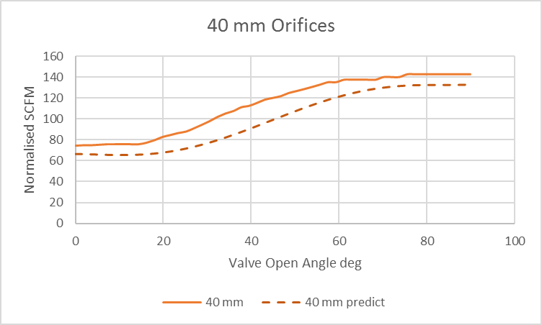

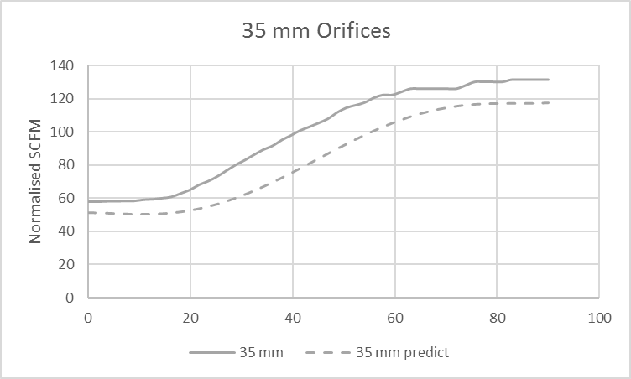

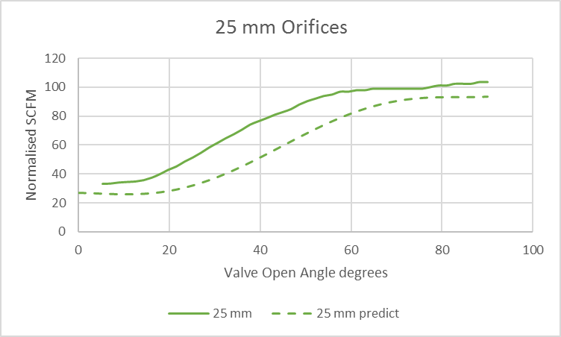

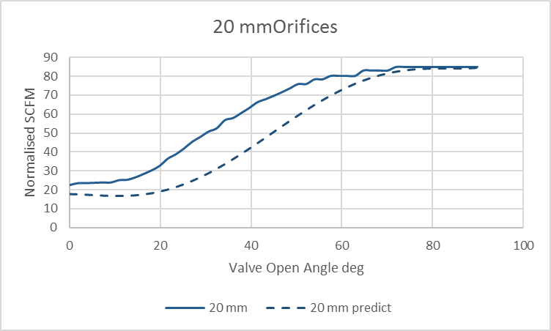

Inspection of these charts indicates the difference in flow between predicted and measured value is actually considerably higher at valve openings between 20 degrees and 60 degrees. The difference at the ends of the ranges may be solely accounted for by the plenum leak, whereas with a partly open valve it looks like the flows are “helping each other by some momentum exchange, rather like an ejector.

This additive effect has been investigated, correlated and characterized in the File…..

**Characterization of Flow through Valve and Orifice Pair Simultaneously**

The calculations for this section can be seen in file # 3234 4NW_Characterization of Flow through Valve and Orifices Simultaneously_Team_SEWEC.xlsx, uploaded to the Team Folde.

The data from the earlier test runs at SJSU was marred by a leaking plenum as well as some valve “sticking” due to the encoder not being activated. Since there was no time to repeat these calibration runs with the modified test rig (due to the rush to get the SEWEC vacuum tested at Orono), we can only use this data to characterize the combined flows. Fortunately the data was easily corrected as follows.

1. Corrections for Valve “sticking”. This correction procedure was adopted for all orifice/valve combinations – the following two charts show the procedure by way of example:

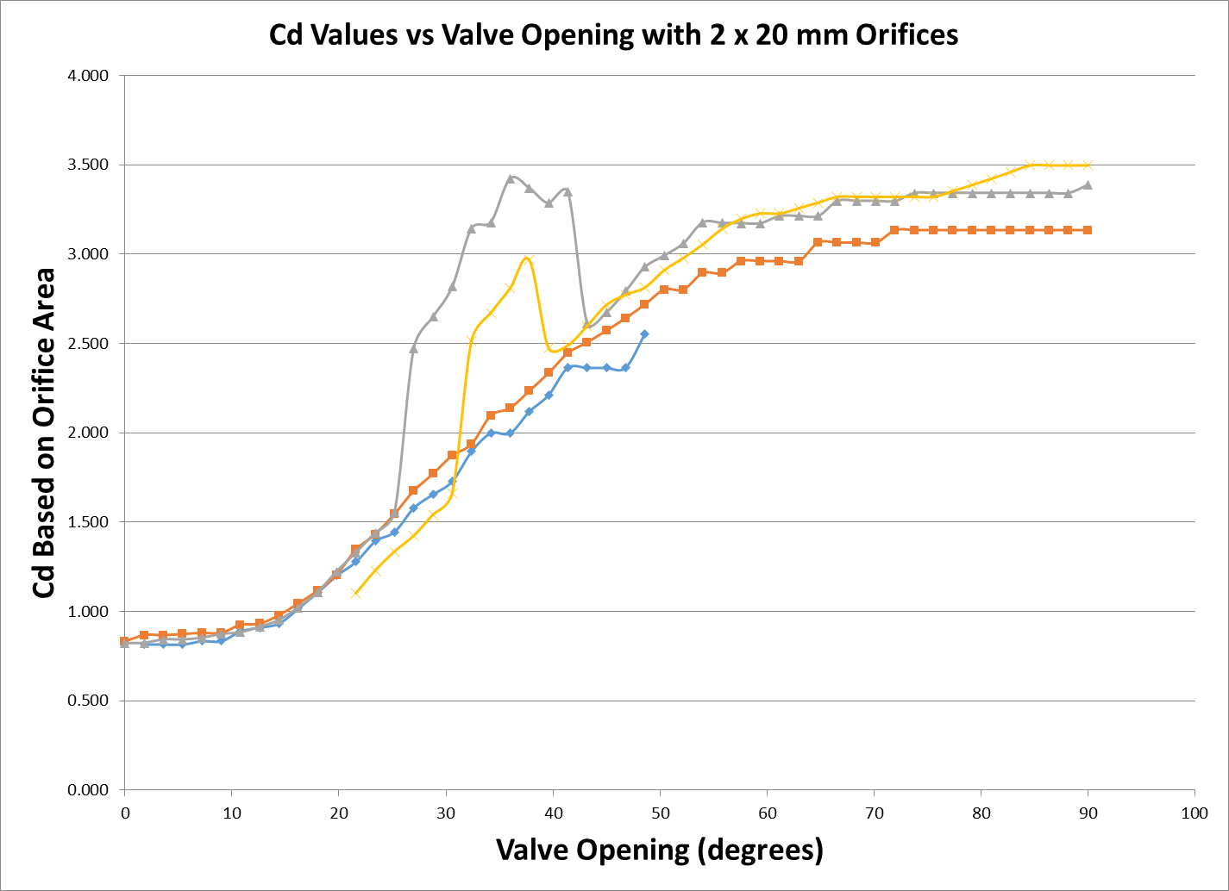

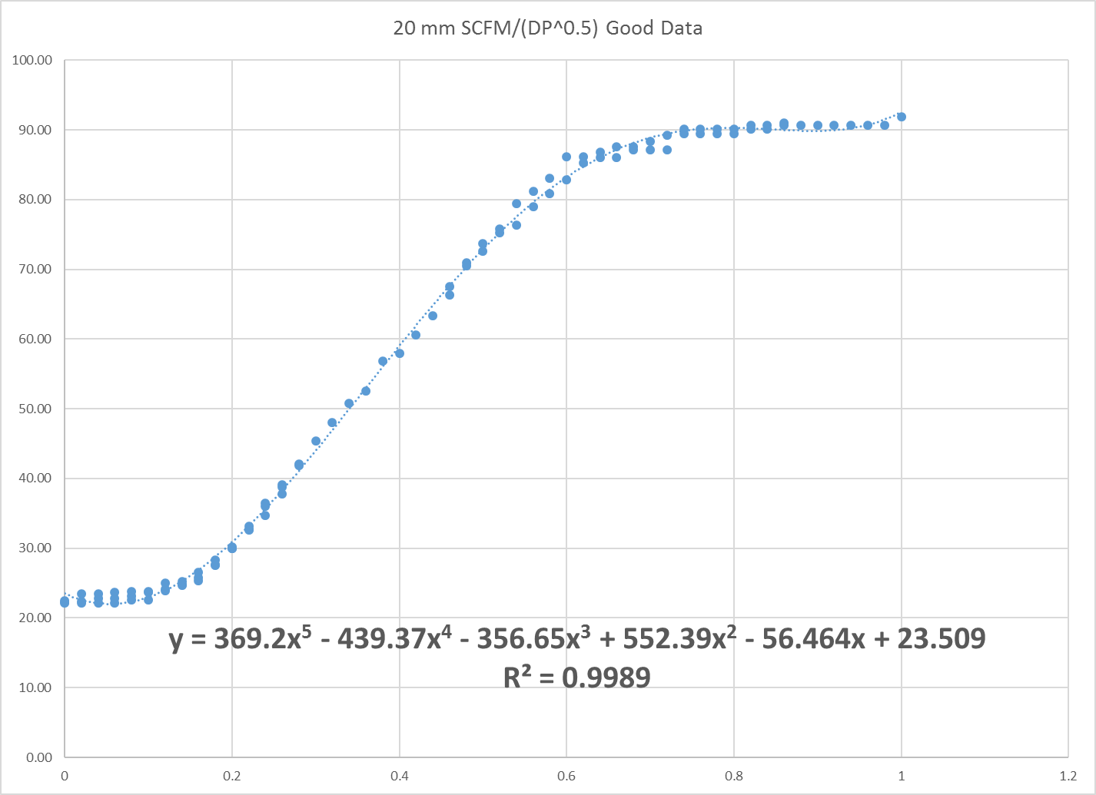

The chart was re-drawn to show SCFM/(DP0.5) instead of Cd and obviously flawed data points were excluded. The trendline correlation is shown on the second chart. Most edited charts show correlations with R2 values above 0.995.

The plot of these correlations is shown below:

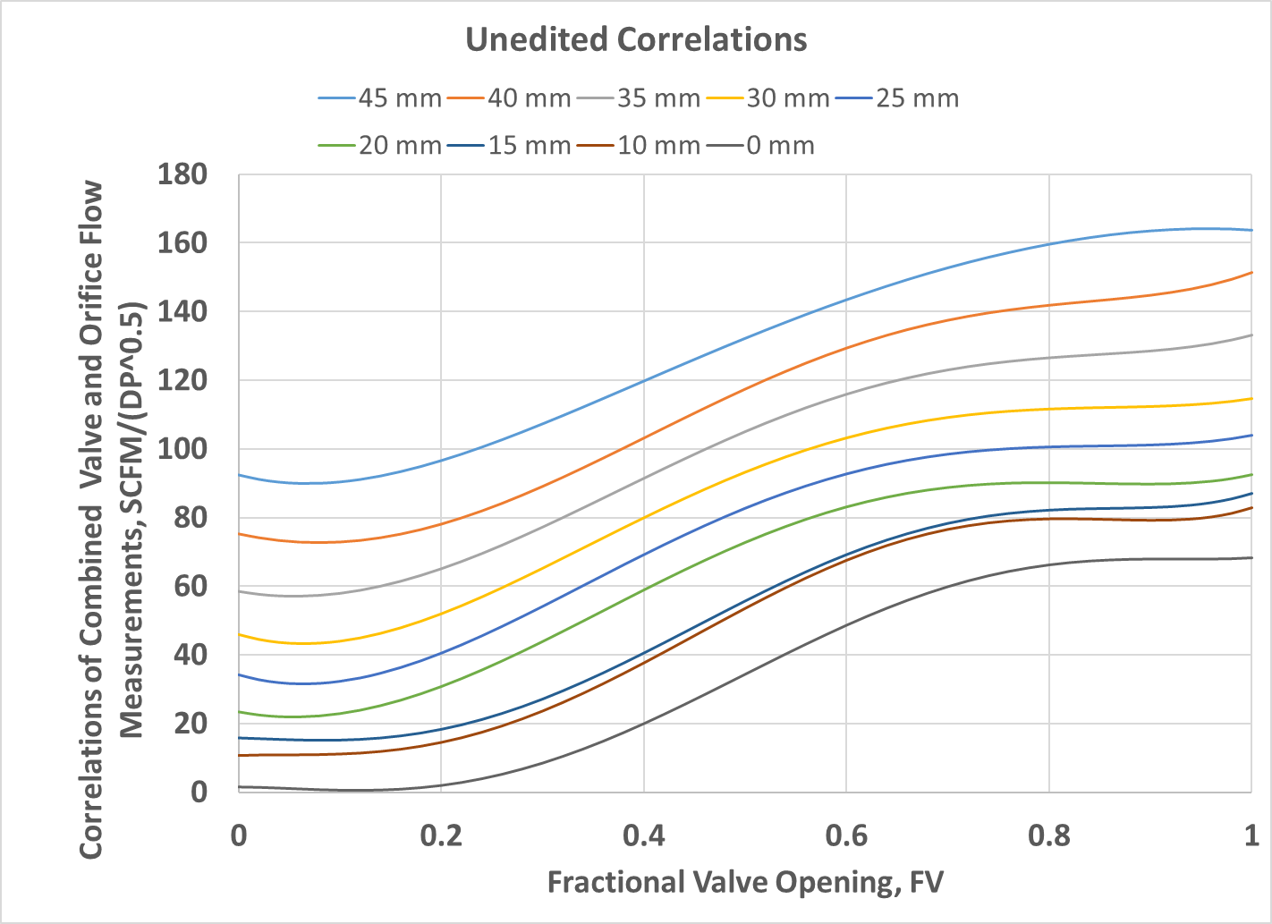

Now we have to correct the chart for the leakage into the plenum. This is easily done since we know the flow for each configuration with the valve at 0 degrees from the tests with the modified (leak free) test rig. The chart below shows the chart after correcting such that the correct flow is shown at the valve closed position.

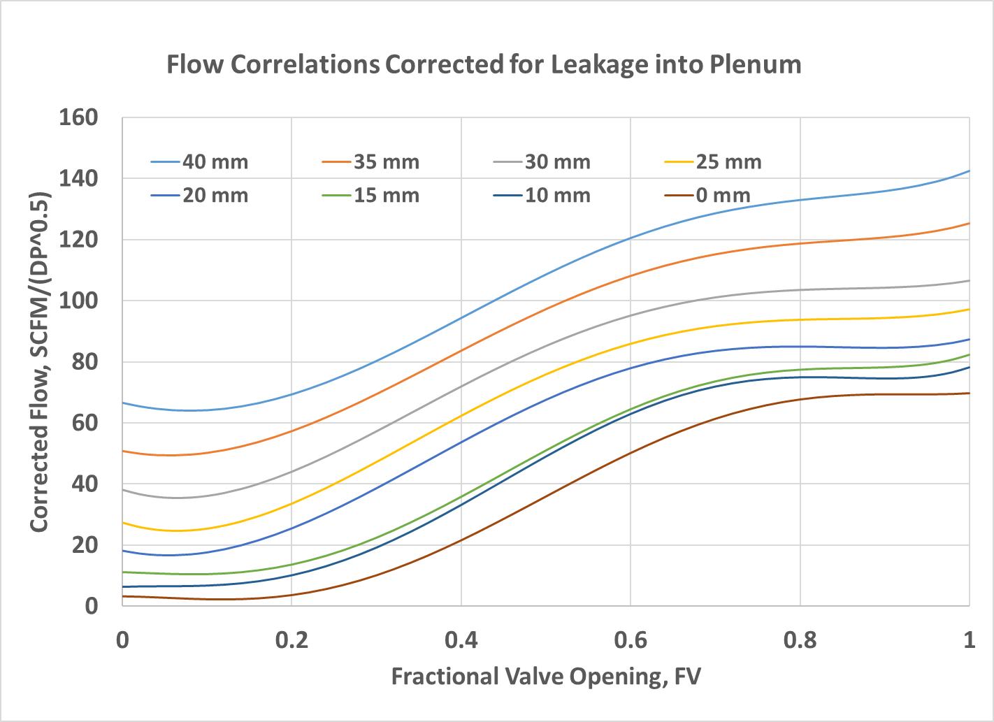

This data is then further processed by subtracting, for each orifice size, the flow through the valve alone (i.e. 0 mm orifice).

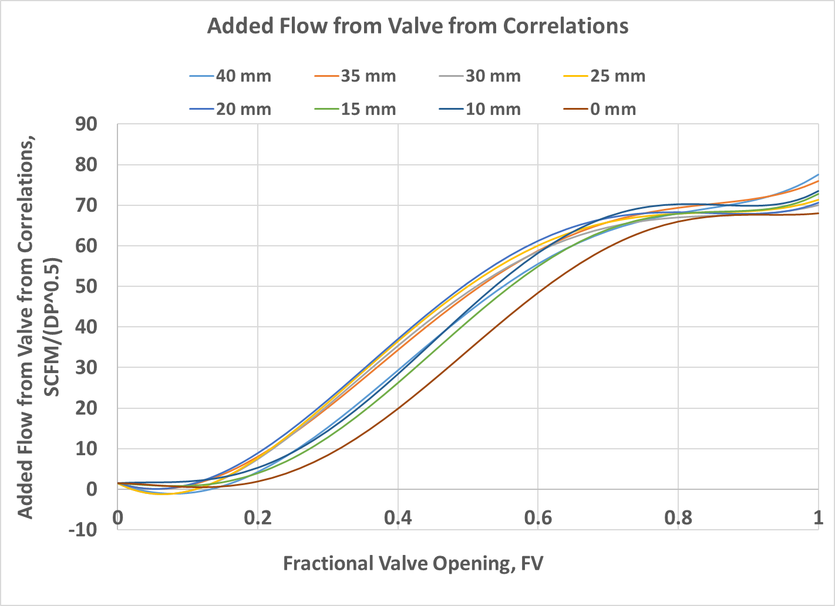

It is clear that the flow through the valve is always higher between 20% and 70% valve opening if there is an orifice installed - this is presumably an eductor effect, caused when the angled jet from the valve crosses over the exiting the orifice. The chart below shows the difference between the flow through the valve with each orifice size and the flow through the valve with the orifice blanked.

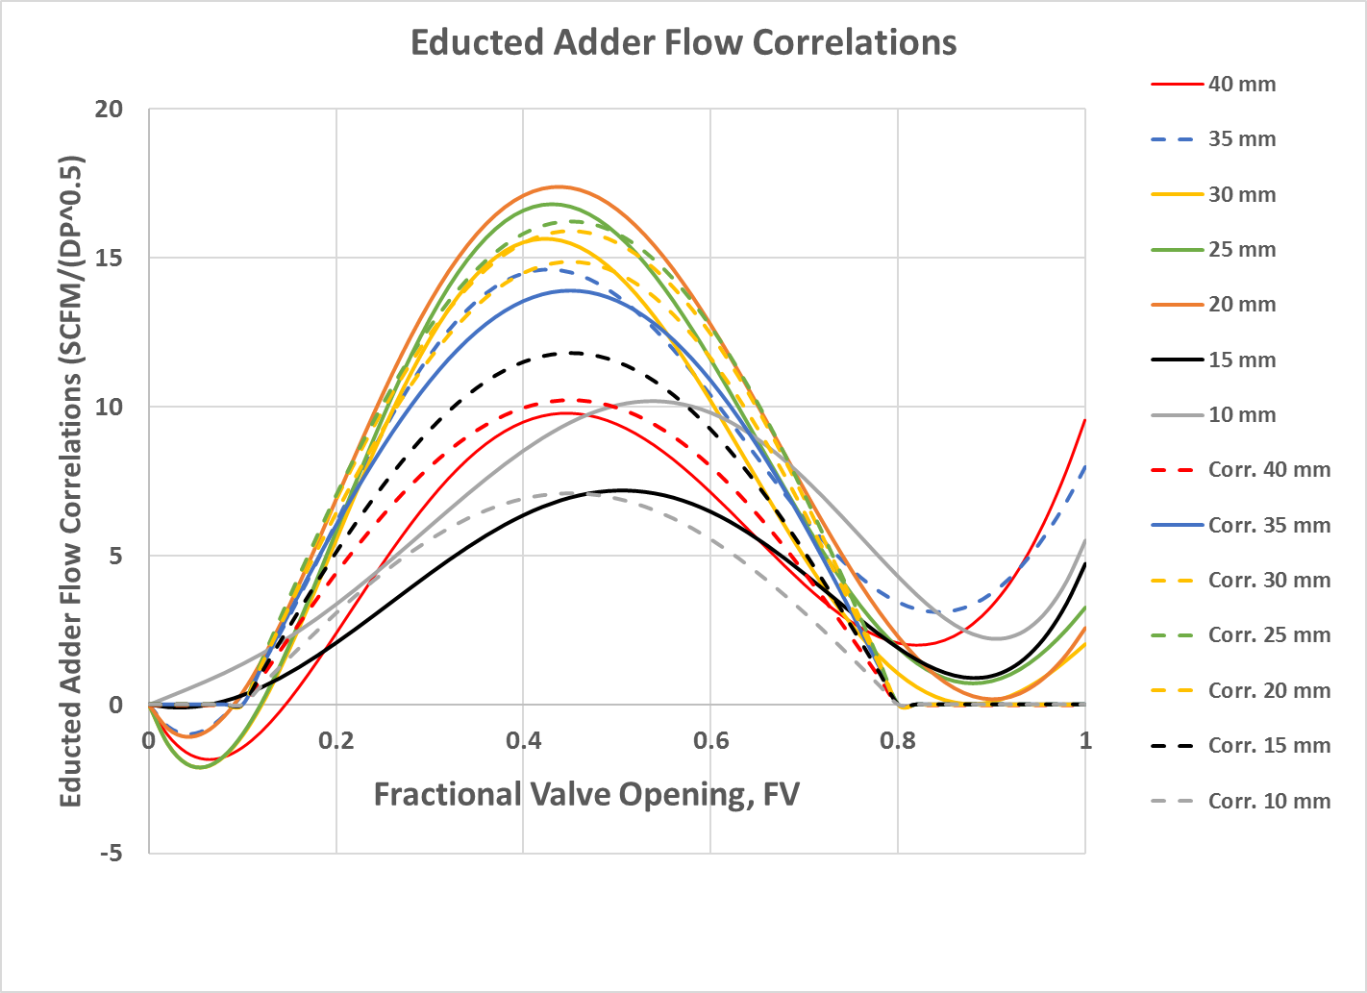

Correlations of this “Educted Adder Flow” have been included for each orifice size.

Based on the above, we characterize the flow through the combined orifice pair and Valve as follows:

SCFM/(DP0.5)total =

SCFM/(DP0.5)orifices alone + SCFM/(DP0.5)valve alone + SCFM/(DP0.5)eductor added flow

Where SCFM is flow in SCFM, DP is pressure difference in inches H2O

Orifices alone:

SCFM/(DP) 0.5= 25834*A, or SCFM = 25834*A*DP0.5

where SCFM is the airflow in SCFM, DP is the pressure difference in inches H2O and A is the total orifice area in m2

Valve alone:

SCFM/(DP) 0.5 = a*FV5 + b*FV4 + c*FV3 + d*FV2 + e*FV + f

where SCFM is the airflow in SCFM, DP is the pressure difference in inches H2O, FV is the fractional valve opening (open angle/90 degrees) and the constants are:

a = 832.85, b = -2050.4, c = 1484.2, d = -197.55, e = -2.5819, f = 1.6482

Eductor added flow:

if 0.1<FV<0.8,

then SCFM/(DP0.5) = (a*FV2 + b*FV + c)*sin((FV-0.1)/0.7*pi())

else

SCFM/(DP0.5) = 0

where SCFM is the airflow in SCFM, DP is the pressure difference in inches H2O, FV is the fractional valve opening (open angle/90 degrees) and the constants are:

a = 0.0337, b =1.7897, c = -7.445

# Appendix C: Device Froude scaling

* Use the table and equations below as a reference whenever appropriate

|  |  |  |
| --- | --- | --- |
| **Quantity** | **Froude**  **Scaling** | **Reynolds**  **Scaling** |
| wave height and length  wave period and time  wave frequency  power density | *s*  *s0.5*  *s-0.5*  *s2.5* | *s*  *s2*  *s-2*  *s-2* |
| linear displacement  angular displacement | *s*  1 | *s*  1 |
| linear velocity  angular velocity | *s0.5*  *s-0.5* | *s-1*  *s-2* |
| linear acceleration  angular acceleration | *1*  *s-1* | *s-3*  *s-4* |
| mass  force  torque  pressure  power | *s3*  *s3*  *s4*  *s*  *s3.5* | *s3*  *1*  *s*  *s-2*  *s-1* |
| linear stiffness  angular stiffness | *s2*  *s4* |  |
| linear damping  angular damping | *s2.5*  *s4.5* |  |

Froude scaling R(Load), where lower case r is model scale, and capital R is full scale:

Dynamic (force) to kinematic (velocity):

$$\frac{r}{R}=\frac{f}{F}\frac{V}{v}=s^{3}∙s^{-0.5}=s^{2.5}$$

Dynamic (torque) to kinematic (angular velocity):

$$\frac{r}{R}=\frac{τ}{Τ}\frac{Ω}{ω}=s^{4}∙s^{0.5}=s^{4.5}$$

Dynamic (pressure) to kinematic (volumetric flow):

$$\frac{r}{R}=\frac{p}{P}\frac{Q}{q}=\frac{p}{P}\frac{V}{v}\frac{L^{2}}{l^{2}}={s∙s}^{-0.5}∙s^{-2}=s^{-1.5}$$

**Accounting for Air Compressibility when Scaling**

Numerical simulations of OWC scale model devices usually include the assumption that the air is incompressible – quite reasonable because at small scale the pressure changes involved are small relative to atmospheric pressure. This assumption masks the unfortunate fact that it is quite difficult to account for air compressibility at full scale when building a small scale model. Our team therefore appreciates recent input from WEP/PAT and the judges on why the scaling problem cannot be wished away.

We have reviewed the references provided by the judges (Falcao and Henriques and XXX &yyyyy) and considered the following ways of accounting for air compressibility.

1. *Increase the volume of air undergoing cyclical compression and expansion by a factor of twenty.* The volume of air in our device is approximately 140 liters. A twenty times larger volume is 2.8 m3, e.g. a sphere of 6 feet diameter. We could not include this on the device – such a volume would have to be held in a rigid closed container and mounting such a container on our device would totally obscure its dynamic behavior (principally pitching mass, C of G and moment of inertia. Piping our pitching, heaving and surging device up to a bridge based container without imparting restraining or pressure based loads on our device would also be impossible. We note this could be done for the Portuguese OWC referenced in the Falcao and Henriques paper, but this involved a land based OWC where the problems mentioned above do not arise.
2. *Reduce the air pressure in the device by a factor of twenty*. Although the judges indicated a preference for measure (i) in an April response to our team, the possibility of running at reduced pressure to give the same effect was also raised. This is uniquely possible in principle with the SEWEC type of OWC because the device works without inhaling and exhaling air. The same air is alternately compressed, expanded and partially exchanged between two chambers, isolated from the atmosphere. On hearing that this could be a solution to the scaling problem we immediately changed the design of our scale model’s internal chamber from Design A to Design B below:

|  |  |  |
| --- | --- | --- |
|  | Design A no vacuum | Design B for full vacuum |
| Design Features | 28” ID aluminum pipe with internal 21” ID polystyrene foam sleeve | 21” ID aluminum pipe, no internal foam sleeve |
| Appling vacuum results in | Foam bubbles will burst, foam would disintegrate. Aluminum pipe will collapse under external pressure. | No internal foam. Reduced pipe ID with selected wall thickness (1/8th inch) is stable and will not collapse under vacuum - per ASME Code Section VIII calculation made by Tom Johansing of pipe fabricator Johansing Iron Works. |

1. *As a last resort – numerical modelling.* The requirement is that teams must supply numerical modelling results that quantify the performance of their 1/20th scaled device modeled with an air volume ratio per (i) above relative to their 1/20th scaled device with an air volume ratio = (1/20)3. Numerical model results comparing the two cases should be plotted as dimensionless absorbed power vs. dimensionless wave frequency for each sea state tested at MASK (see Fig. 7 in Falcao and Henriques, 2014). The results of this numerical model comparison will be taken into account by the Judges at the final gate.

**Team SEWEC Approach (as of 05-13-16)**

We are of the opinion that measure (i) above is impractical for a floating device like SEWEC that captures energy by pitching in the waves. Measure (ii) is potentially workable, but is untried in practice. Potential issues are listed below:

|  |  |  |
| --- | --- | --- |
| Basis: “Vacuum” = 0.05 atm  **Issue** | **Potential problems** | **Steps to avoid/mitigate** |
| Maintaining vacuum | Leakage greater than pumpout rate. This is unlikely – our device is sealed, the only potential leak path is via the butterfly valve bushing. Leakage here would easily be handled by a simple vane pump at 0.05 atm and would be small compared to the volume passing between chambers. | Check all o rings and flange gaskets correctly installed, make leak test |
| Withstanding vacuum | An external pressure of 1 atm can easily collapse most closed containers. Closed cell foam will explode. | Pipe ID reduced, internal foam removed, ASME VIII vacuum calculation made. |
| Measuring under vacuum conditions | Water level/volume change measurement not affected.  DP transducer must withstand vacuum.  Condensation inside the DP transducer (membrane type) would wreck the reading. The high water vapor concentration at 0.05 atm (40% -50%) could be a problem here. | Because transducer design pressure is 5 psi, DP transducer must be installed inside one chamber with one input ported from the other chamber. We are planning to have DP transducer outside the air chamber to make it accessible for spot checks – so we may have to compromise here. |
| Scaling performance from vacuum conditions | Likely the saturated air/water vapor mixture will fog on expanding and defog on compression. Hard to model…. | Reduce water vapor pressure by (a) admixing glycol or (b) use ice/water slurry. |

Until we have tried this mode of operation and worked out any bugs we cannot be sure to get this to work – the devil is surely in the details.

With regards to numerical modelling we had hoped to satisfy the judges that the discrepancies resulting from Froude scaling can be accurately quantified by numerical modelling and confidently used to adjust the results from our Froude scale model tests.

To do this we have retained the service of an expert consultant in this field, Dr. Wanan Sheng , Research Fellow at University College, Cork. [http://research.ucc.ie/profiles/D012/wsheng](http://research.ucc.ie/profiles/D012/wsheng%20) Dr. Sheng is the author of a number of peer reviewed papers on this topic. More importantly Dr. Sheng is intimately acquainted with the SEWEC device, using his WAMIT based time domain simulation to model device performance for a number of scale model tests, including our team’s 1/50th scale tests at the U of M in December last year as well as assisting us with the WEP inputs relating to numerical modelling and limited control strategy.

Dr Sheng has already completed the first step, adapting his model to treat air as a compressible fluid. We have just asked him to explain how he has done this. Here is his response:

*“In the numerical modelling, the pitching motion of the device and the internal water motion are coupled by applying a power take-off (PTO). To accommodate the air compressibility, the method developed by (Sheng, Alcorn et al. 2013, Sheng, Alcorn et al. 2014, Sheng, Alcorn et al. 2014) has been adopted in such a way that the device motion, internal water body and the thermodynamics (i.e., the chamber pressure) are solved in time domain. By comparison, if the air compressibility is not considered, then the volume change rate in the air chamber will all pass through the PTO, no thermodynamic equation will be solved.”*

In addition, he has asked us to list the following reference papers on this topic.

Sheng, W., et al. (2013). "On thermodynamics of primary energy conversion of OWC wave energy converters." Journal of Renewable and Sustainable Engineering 5(023105): 023105.

Sheng, W., et al. (2014). "Assessment of primary wave energy conversions of oscillating water columns. I. Hydrodynamic analysis." Journal of Renewable and Sustainable Engineering 6: 053113.

Sheng, W., et al. (2014). "Assessment of primary wave energy conversions of oscillating water columns. II. Power take-off and validations." Journal of Renewable and Sustainable Energy 6: 053114

In addition to the two requested cases (1/20th scale with compressible air and 1/8000 volume and 1/400 volume) we propose to simulate two additional cases, i.e. (a) 1/20th scale with compressible air, 1/8000 volume and 0.05 bar and (b) full scale with compressible air.

In order to provide the confidence required, these simulations must be run with the SEWEC ballasting and PTO damping values (SEWEC adaptive control) optimized for the particular wave configuration – that will be our test condition. As of May 13th, we have not yet determined what this will be. We are currently running a number of numerical models to determine this and plan to check these out in 1/20th scale tests at the University of Maine in early July. Only after establishing these “start test parameters” will we be able to provide Dr. Sheng with the adapted device properties to simulate. Even then, on the day - in Carderock, we may find a better configuration for an individual sea state. In this case we will ask Dr. Sheng to re-run the simulations so they simulate our best runs in Carderock, and provide the revised input to WEP prior to Gate 4, as stipulated.

In summary, our initial approach was:

1. Take all possible steps to be able to run under vacuum while building the device.
2. Run the tests at ambient pressure and provide numerical modelling as outlined above.
3. If we get time, try a test under vacuum at Carderock as confirmation for one wave condition.

Per the information received as of TG3, this approach seems to have been rejected by the judges. Accordingly we have taken steps to configure the device for vacuum operation. On July 12th thru 16th the device was uncrated at the University of Maine and vacuum tested. After tightening some hose clamps the device reached a vacuum of 0.28 psia steady state with a 10 m3/h oily vane vacuum pump. After setting the internal air chamber pressure to 0.75 psia (0.05 atm), the pressure rose to 0.80 psia in 10 minutes with the vacuum pump disconnected.

# Appendix D: Detailed description of control strategy

Our Control strategy is based on optimizing the relationship between the key Naval Architecture variables inherent in the device design: namely CoG, MoI, Centre of Buoyancy , Mass distribution and Metacentre. Additionally the damping applied affects the device conversion efficiency.

The objective of the strategy is to have the facility to tune the device to the prevailing sea state maximizing the power output. This objective can be achieved by adjusting the ballast arrangements in the device together with the damping. Obviously there is a large number of variations available and it has not been possible to investigate the range during tank testing. However our testing to date confirms that it is entirely feasible to adjust the natural period of oscillation of the device to match the predominant wave period maximizing the conversion efficiency using the above tactics.

Accordingly we have conducted extensive numerical modeling, and will continue with this, to inform our physical tank testing . PreTesting of the 1/20th scale model in the UoM basin will permit us to validate our numerical modeling and also to verify our methods of physically adjusting the device configuration from wave case to wave case maximizing conversion efficiency.

The numerical modeling approach adopted is the subject of a separate report which also addresses air compressibility effects which have to be taken into account.

A detailed description of how the strategy is physically implemented and the tactics used is given in section 4.6 above.

# Appendix E: Raw Data Channel list

|  |  |  |  |  |  |  |  |
| --- | --- | --- | --- | --- | --- | --- | --- |
| **Instructions** |  |  |  |  |  |  |  |
| *Data File:* |  | The name of the data file where the data resides | |  |  |  |  |
| *Channel Name:* |  | The name of the data channel in the data file - if data are in a matrix, this is the index (column number) of the data in the matrix | | | |  |  |
| *Channel Title:* |  | The common named use to refer to the data in the channel | |  |  |  |  |
| *Description:* |  | Description of what is being measured/recorded | |  |  |  |  |
| *Unit:* |  | The unit of the measurement as output by the DAS | |  |  |  |  |
| *Sensor* |  | The name of the sensor. Please provide enough information so a reader can identify the specific type of sensor used | | | |  |  |
| *Sample Rate* |  | The sample rate of the data record | |  |  |  |  |
| *Scaling and Conversion Calculations* | | Where the measured values will be used | |  |  |  |  |
|  |  |  |  |  |  |  |  |
| **Data File** | **Channel Name** | **Channel Title** | **Description** | **Unit** | **Sensor** | **Sample Rate** | **Scaling and Conversion Calculations** |
|  | Mooring Tension 1 |  |  |  |  |  | See data file for conversions used during testing |
|  | Mooring Tension 2 |  |  |  |  |  |  |
|  | Wave Height 1 |  |  |  |  |  |  |
|  | Wave Height 2 |  |  |  |  |  |  |
|  | Wave Height 3 |  |  |  |  |  |  |
|  | Wave Height 4 |  |  |  |  |  |  |
|  | Wave Height 5 |  |  |  |  |  |  |
|  | Wave Height 6 |  |  |  |  |  |  |
|  | Wave Height 7 |  |  |  |  |  |  |
|  | Wave Height 8 |  |  |  |  |  |  |
| CH1_DP1.csv | Channel 1 | DP1 | Differential pressure from 160PC1D36 #1 | Volts | 160PC1D36 | 100Hz | DP [“H20] = ( Voltage [V]– 3.5 [V] ) * 2 [“H20 / V] |
| CH2_DP2.csv | Channel 2 | DP2 | Differential pressure from 160PC1D36 #2 | Volts | 160PC1D36 | 100Hz | DP [“H20] = ( Voltage [V]– 3.5 [V] ) * 2 [“H20 / V] |
| CH3_Depth1.csv | Channel 3 | Depth probe 1-11 | Depth probe in position 11 | Volts | SEWEC-EE-02 1 | 100Hz |  |
| CH4_Depth2.csv | Channel 4 | Depth probe 1-12 | Depth probe in position 12 | Volts | SEWEC-EE-02 2 | 100Hz | See Appendix H |
| CH5_Depth3.csv | Channel 5 | Depth probe 1-21 | Depth probe in position 13 | Volts | SEWEC-EE-02 3 | 100Hz | See Appendix H |
| CH6_Depth4.csv | Channel 6 | Depth probe 1-22 | Depth probe in position 14 | Volts | SEWEC-EE-02 4 | 100Hz | See Appendix H |
| CH7_Depth4.csv | Channel 7 | Depth probe 2-11 | Depth probe in position 21 | Volts | SEWEC-EE-02 5 | 100Hz | See Appendix H |
| CH8_Depth5.csv | Channel 8 | Depth probe 2-12 | Depth probe in position 22 | Volts | SEWEC-EE-02 6 | 100Hz | See Appendix H |
| CH9_Depth5.csv | Channel 9 | Depth probe 2-21 | Depth probe in position 23 | Volts | SEWEC-EE-02 7 | 100Hz | See Appendix H |
| CH10_Depth5.csv | Channel 10 | Depth probe 2-22 | Depth probe in position 24 | Volts | SEWEC-EE-02 8 | 100Hz | See Appendix H |
| CH11_Position.csv | Channel 11 | Valve Position | Position of valve from quadrature encoder | Counts | PKP264D07AA-R26-L | N/A, Interrupt basis | 0.9 degrees / count from zero |
| CH12_AP.csv | Channel 12 | P1 | Absolute pressure within core tube | Volts | PX309 | 100Hz | P [“H20] = 6.195 [“H20/mA] * I [mA] |
|  |  |  |  |  |  |  |  |
|  |  |  |  |  |  |  |  |

# Appendix F: Checklists for spot checks, software operation, readiness verification, and “real time” data QA

Pressure sensor spot check

|  |  |  |  |
| --- | --- | --- | --- |
| No | Reference reading  (in H2O) | Differential Pressure Reading (in H2O) | 100 x (Reference Reading - Differential Pressure Reading)/Reference Reading (%) |
|
| 1 |  |  |  |
| 2 |  |  |  |
| 3 |  |  |  |
| 4 |  |  |  |
| 5 |  |  |  |
| 6 |  |  |  |
| 7 |  |  |  |

Probe-derived pitch angle spot check

|  |  |  |  |
| --- | --- | --- | --- |
| No | Reference reading (rad) | Probe-derived Pitch (rad) | 100 x (Reference Reading - Probe-derived Pitch)/Reference Reading (%) |
|
| 1 |  |  |  |
| 2 |  |  |  |
| 3 |  |  |  |
| 4 |  |  |  |
| 5 |  |  |  |
| 6 |  |  |  |
| 7 |  |  |  |

Probe-derived roll angle spot check

|  |  |  |  |
| --- | --- | --- | --- |
| No | Reference reading (rad) | Probe-derived Roll (rad) | 100 x (Reference Reading - Probe-derived Roll)/Reference Reading (%) |
|
| 1 |  |  |  |
| 2 |  |  |  |
| 3 |  |  |  |
| 4 |  |  |  |
| 5 |  |  |  |
| 6 |  |  |  |
| 7 |  |  |  |

# Appendix G: Team provided sensors – specifications and calibrations

The team provided sensors are detailed in Table H.

|  |  |  |  |  |
| --- | --- | --- | --- | --- |
| Item No. | Function | Part No. | Signal | Range |
| D1 | Differential Pressure | 163PC01D36 | 3.5 – 6V | -5 to +5 in H20 |
| D2 | Water Level | SEWEC-EE-02 | |  |  | | --- | --- | | 0.0-0.5V | See Below | | |  |  | | --- | --- | | 0.0-0.5V | See Below | |
| D6 | Device rotation  Valve Position | SEWEC-EE-01 | Network  Network | 0 – 360 deg.  0 – 90 deg. |

**Table H. Team provided sensors list**

**Differential pressure** across the variable orifice is measured with a Honeywell 160PC Series low pressure sensor which is procured with certificates of conformance ensuring the specified performance shown below:

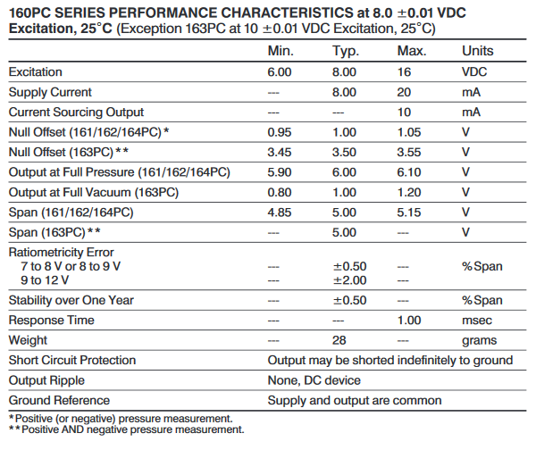

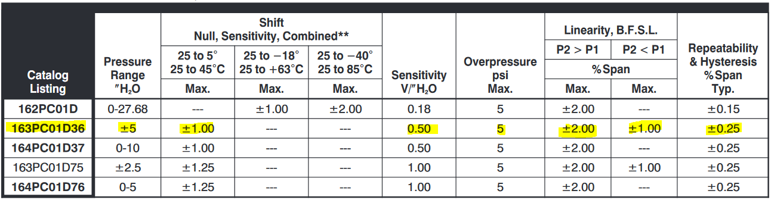

Although the manufacturer certifies the material used and performs acceptance testing on the delivered product, verification of the pressure output through the measurement chain are performed as part of the valve calibration process. Calibration data is provided as an excel attachment.

A calibrated volt-meter PN: FLUKE 45 (or equivalent) shall be used for signal measurement

**Water level** is measured with depth probes installed in the inner diameter of the device water chamber. Each probe consists of a pair of 1/8th inch diameter stainless steel rods spaced ¼ inch apart. The resistance across the rod pair is inversely proportional to the length of probed immersed. A controlled current source (maximum 0.3 amps) drives a precision current through the probe. Voltage drop across the element is measured with a voltmeter on the bridge to obtain effective resistance of the element. Water level calibration is performed by characterization of the resistance measured as the element is rotated in the chamber at 5 degree intervals over a 60 degree [TBC] belt within the device. The measurements are then conformed to a curve obtained via regression analysis of the calibration measurements. The angular displacement v.s. Resistance curve is then correlated to water level through the device geometry.

The resistance of the water is the electrical property of primary interest so the probes have to be calibrated with the water in which they will be used. = [1]

Each probe has a path length defined by the geometry shown in Figure 1. Since there are two end plates, there are a total of 8 probes labeled (11), (12), (13), (14), (21), (22)…(24), where the first number represents the plate, and the second number represents the probe as depicted in the figure.

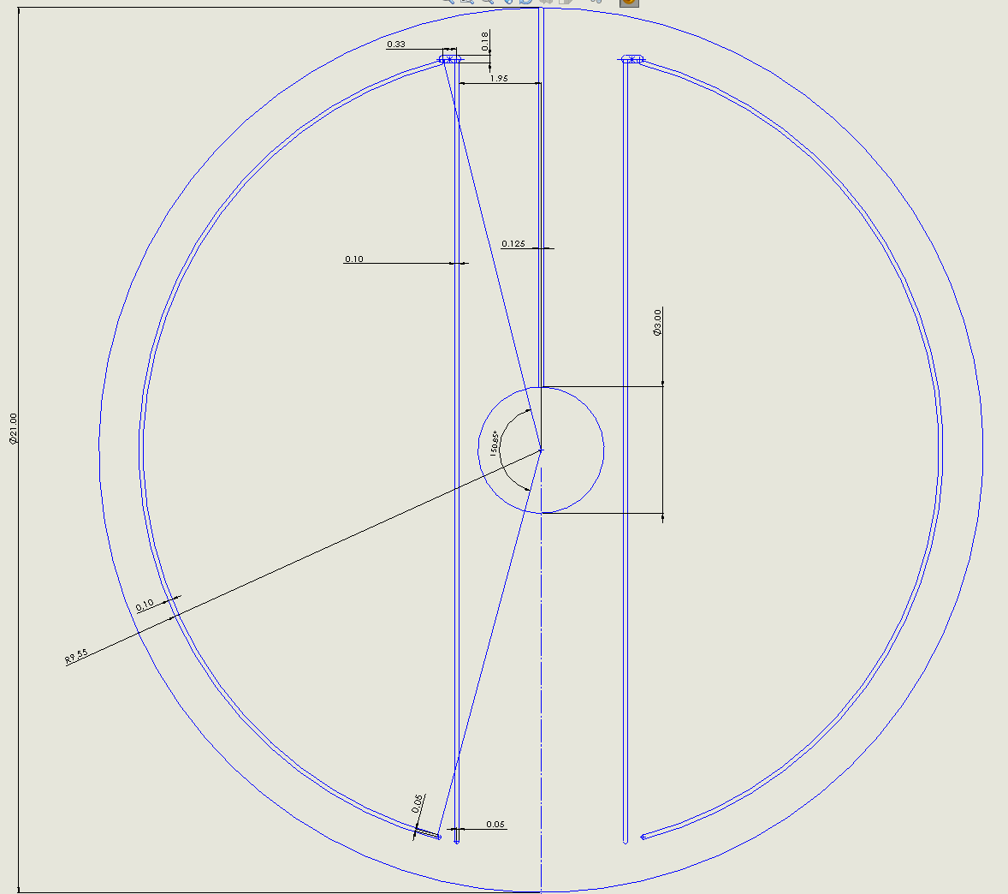

4

1

3

2

Calculated resistances are used for spot-checking, and actual measured values with calibrated instrumentation should be used in testing; in other words the measured resistance should not deviate from the calculated value during spot checks. In order to calculate the volume, dry resistances are determined, points of reference along the geometry based on measured and base resistances are established, and finally definition of the level plane and volume are obtained through a linear transformation.

**Dry Resistance and Points of Reference**

From the geometry the lengths of the 1/4 probes are:

= = = =r*theta [2]

Where, is the radius from center to the probe and is the arc angle of the probe geometry. The “o” indicates the length is at open circuit with no fluid altering the effective length. This leads to dry resistances of:

= For x = 1,2 and y = 1,4. [3]

When submerged in water the effective length of the probe decreases, leading to the ability to obtain the un-submerged length and fluid level/position at the 1/4 corners from the ratio of dry and wet resistance. It is convenient to define the fluid level position as an angle from full rotation which is used later in the final volumetric calculation.

= For x = 1,2 and y=1,4. [4]

Where,

is the angle from the core tube bottom to the water level,

is the measured resistance of the probe, and

is the offset from bottom-dead-center where the probe is installed.

A similar calculation is performed on the 2/3 probes in the center. Their lengths are calculated by the end locations of the probes along the circle which intersects all probes with a radius of .

= = = = [5]

Where, is the distance from the partition to the 2/3 probe installation. In a manner similar to the 1/4 probes, the length submerged (or depth) at 2/3 probes is shown to be [7] from the resistance [6].

= For u = 1,2 and v = 2,3. [6]

= For u = 1,2 and v = 2,3. [7]

**Level Plane Location and Volumetric Calculation**

The level plane in each partition is calculated from the four data points and . To start with, an arbitrary level within the partition shown in Figure 2 intersects the points and .



A straight line is formed through the two points as:

=

=

The volume of the first chamber is calculated by taking the area of the average of the wedges formed at the angle at each end of the device and subtracting the tringle formed from the radius, the line from the two points and the vertical, leaving:

= **AVERAGE PORT TO STARBOARD** ( )

Where, W is the width of the device (port to starboard). This derivation will be used in conjunction with measurements during pre-testing to characterize and formally calibrate the as built configuration.

A calibrated volt-meter PN: FLUKE 45 (or equivalent) shall be used for signal measurement. The accuracy of the measurement is also dependent on the available current source; team SEWEC may supply a precision current source, however a WEP provided device is preferred.

Calculations for the second chamber are made in a similar fashion. If the sum of the calculated volume of the two wedges is not exactly constant, the results will be averaged. If the deviation is significant, we will try to determine the cause.

**Device rotation** is measured using a single board computer (Raspberry Pi) extension with integrated 3 axis accelerometer PN: LSM9DS1 manufactured by STMicroelectronics. Once assembled in the SEWEC device, the sensor measurements will be calibrated by adjusting the pitch to a minimum of 5 positions; the measurements obtained by the LSM9DS1 will be scaled and offset in software as part of the calibration process to obtain at minimum 1% accuracy at all calibration positions. This sensor is not intended for use for official purposes.

**Valve position** is measured using a dedicated quadrature encoder mounted on the valve actuation motor. The encoder has a line count of 400 per resolution providing a over-all resolution of 0.9 degrees. The pressure/flow curve obtained during valve calibration is performed with the actuation and encoder in the loop. During this calibration actual valve deflection angle is measured and verified against the encoder output. The position verification is included with the differential pressure/flow calibration data.

**Absolute pressure** inside the device is measured with an Omega PX-319-005A1 absolute pressure sensor reading 0-5 psia..

**SPECIFICATIONS**  
**Excitation:**9 to 30 Vdc (reverse polarity and overvoltage protected)  
**Output:**4 to 20 mA  
**Accuracy:**±0.25% (includes linearity, hysteresis and repeatability)  
**Zero Offset:**±2% FSO, (±4% 1 and 2 psi)  
**Span Setting:**±2% FSO, (±4% 1 and 2 psi)  
**Total Error Band:**±2% (except 1 psi =±4.5% and 2 psi = ±3%) FSO, includes linearity, hysteresis, repeatability, thermal hysteresis and thermal errors  
**Long-Term Stability (1 Year):**±0.25% typical  
**Typical Life:**10 million cycles  
**Operating Temperature:**-40 to 85°C (-40 to 185°F)  
**Compensated Temperature:**  
   **≤5 psi Range:**0 to 50°C (-18 to 122°F)  
**Proof Pressure:**  
   **psia and ≤50 psig:**3x capacity or 20 psi, whichever is greater  
   **≥100 psi:**2x capacity  
**Burst Pressure:**500% capacity or 25 psi, whichever is greater  
**Response Time:**<1 ms  
**Shock:**50 g, 11 ms half-sine shock  
**Vibration:**±20 g  
**Wetted Parts:**316 SS for all psia ranges and 1 to 50 psig; 17-4 PH SS for ranges 100 to 10,000 psig  
**Pressure Port:**1/4 -18 MNPT  
**Electrical Connections:**  
   **PX319:**mini DIN connector with mating connector included  
**Weight:**155 g (5.4 oz) max

# Appendix H: Data analysis details

The following time series will be plotted for each run and be available for viewing between runs (if time permits)

| Variable | Definition | Reference Formula | Relevant Runs |
| --- | --- | --- | --- |
| Displacement – Inertial Frame | X is defined relative to the 0 deg wave heading, Z is upward and Y completes the right hand rule | $$X= \left[X,Y\right]$$ | All |
| Mooring Tension for each line | The instantaneous value of the mooring tension for line j | $$F_{j}$$ | All |
| Kinematic Power | Kinematic Side of Power for PTO j | $${kin}_{j}$$ | All |
| Dynamic Power | Dynamic Side of Power for PTO j | $${dyn}_{j}$$ | All |
| Absorbed Power | Absorbed power for PTO j | $$P_{j}$$ | All |

The following variables will be calculated for each run and be available for viewing between runs (if time permits)

| Variable | Definition | Reference Formula | Relevant Runs |
| --- | --- | --- | --- |
| Wave PSD | Spectral density of the water surface elevation | $$S_{H}\left(f\right)$$ | All |
| Significant Wave Height | Measured significant wave height | $$H_{m_{0}}=4\sqrt{m_{0}}$$ where $$m_{i}=\sum_{{k=f}_{0}}^{f_{N}}{f_{k}^{i}S_{k}\left(f\right){∆f}_{k}}$$ | All |
| Omni-Directional Wave Energy Flux | Omni-Directional Wave Energy Flux | $$J= ρg\sum_{{k=f}_{0}}^{f_{N}}{S_{k}\left(f\right)C_{gk}{∆f}_{k}}$$ $$C_{gk}= \frac{1}{2}C_{pk}\left[1+\frac{2k_{k}h}{\sinh\left(2k_{k}h\right)}\right]$$ $$C_{pk}= \sqrt{\frac{g}{k_{k}}\tanh\left(k_{k}h\right)}$$ | All |
| Wave Energy Period | Wave Energy Period | $$T_{e}=\sqrt{\frac{m_{-1}}{m_{0}}}$$ | All |
| Horizontal Displacement | Horizontal displacement of the WEC from its at rest position | $$Υ=\sqrt{X^{2}+Y^{2}}$$ | All |
| Mean | The mean value of the mooring tension for line j | $$\overline{F_{j}}=\frac{1}{N}\sum_{i=1}^{N}{F_{j_{i}}}$$ | All |
| Standard Deviation | The standard deviation of the mooring tension for each mooring line | $$σ_{F_{q}}=\sqrt{\frac{1}{N-1}\sum_{i=1}^{M}{{\left(F_{j_{i}}-\overline{F_{j}}\right)}^{2}}}$$ | All |
| Max | The maximum value of the mooring tension of all mooring lines | $$max\left(F_{j}\right)$$ | All |
| Min | The minimum value of the mooring of all mooring lines | $$min\left(F_{j}\right)$$ | All |
| Mean | The mean value of the kinematic side of power for PTO j | $$\overline{{kin}_{j}}=\frac{1}{N}\sum_{i=1}^{N}{{kin}_{j_{i}}}$$ | All |
| Standard Deviation | The standard deviation of the kinematic side of power for PTO j | $$σ_{{kin}_{j}}=\sqrt{\frac{1}{N-1}\sum_{i=1}^{M}{{\left({kin}_{j_{i}}-\overline{{kin}_{j}}\right)}^{2}}}$$ | All |
| Max | The maximum value of the kinematic side of power | $$max\left({kin}_{j}\right)$$ | All |
| Min | The minimum of the kinematic side of power for PTO j | $$min\left({kin}_{j}\right)$$ | All |
| Kinematic spectral density | Spectral density of the kinematic side of power for PTO j | $$S_{{kin}_{j}}\left(f\right)$$ | All |
| Mean | The mean value of the dynamic side of power for PTO j | $$\overline{{dyn}_{j}}=\frac{1}{N}\sum_{i=1}^{N}{{dyn}_{j_{i}}}$$ | All |
| Standard Deviation | The standard deviation of the dynamic side of power | $$σ_{{dyn}_{j}}=\sqrt{\frac{1}{N-1}\sum_{i=1}^{M}{{\left({dyn}_{j_{i}}-\overline{{dyn}_{j}}\right)}^{2}}}$$ | All |
| Max | The maximum value of the dynamic side of power | $$max\left({dyn}_{j}\right)$$ | All |
| Min | The minimum of the dynamic side of power | $$min\left({dyn}_{j}\right)$$ | All |
| dynamic spectral density | spectral density of the dynamic side of power, one for each power conversion chain of the WEC | $$S_{{dyn}_{j}}\left(f\right)$$ | All |
| Mean | The mean value of the power | $$\overline{P_{j}}=\frac{1}{N}\sum_{i=1}^{N}{P_{j_{i}}}$$ | All |

This page intentionally left blank